Frequently Asked Questions (FAQs)
- Is COMEMR compatible with other healthcare systems and platforms?
Yes, COMEMR is designed to be interoperable with existing healthcare systems and platforms, including electronic medical record (EMR) systems, health information exchanges (HIEs), and national health databases. It supports integration through standard protocols such as HL7 and FHIR. The latest release introduces the FHIR Adapter, which simplifies data exchange by translating COMEMR data into the widely used FHIR format. This adapter enables seamless integration with FHIR-compatible systems and facilitates centralized data storage and exchange, including interoperability with DHIS2 systems used in Africa and Bangladesh.
- Can I customize workflows in COMEMR to suit my organization's needs?
While non-clinical workflows are customizable to suit organizational needs, clinical decision support features are not customizable. However, users have the flexibility to customize parameters and create custom workflows for non-clinical tasks.
- How secure is the data stored in COMEMR?
Security is a top priority for COMEMR. The platform employs robust encryption protocols and access controls to safeguard sensitive patient information. All data is encrypted at rest and in transit. We perform regular security audits and vulnerability testing on the platform and ensure compliance with standards and regulations to ensure data integrity and confidentiality. See Data Privacy & Security for more information.
- What kind of support is available for COMEMR users?
For any support or additional questions, please reach out to community@medtroniclabs.org. Medtronic LABS provides comprehensive support to users through various channels, including online documentation, GitHub discussions, and 1:1 support. Users can access role-specific guides to better understand workflows and get answers to functionality questions. See Support for more information.
- How often is COMEMR updated, and are there any additional costs for updates?
COMEMR undergoes regular updates and enhancements to introduce new features, improve performance, and address user feedback. For implementations leveraging the hosted model, updates are typically rolled out periodically, and there are no additional costs for receiving updates. For implementations leveraging the open-source packages, we send release notification emails to the newsletter subscribers. See Support and Releases for more information.
- Can COMEMR be used in offline environments or areas with limited internet connectivity?
Yes, COMEMR offers offline functionality, allowing users to perform essential tasks even in environments with limited or no internet connectivity. Data captured offline is synced with the central server once an internet connection is restored, ensuring continuity of care and data integrity.
- What are the processes for logging into the COMEMR portal?
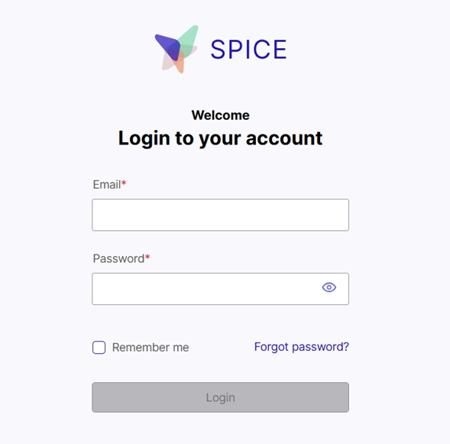
Portal Login
Steps to Log In
- Enter Your Username or Email
a. This is usually the first input field.
b. Enter your registered email address or username.
- Enter Your Password
a. Use the second input field to enter your password.
b. If you're unsure, click the eye icon to see what you're typing.
- Click the Login Button
a. After entering your credentials, click the Login button.
- Trouble Logging In?
a. Click "Forgot Password" if you don’t remember your password.
b. Follow the instructions to reset it.
- Checking the “Remember me” box will store your user details.

